**Vikrant Harish - Personal Portfolio**

(Team 3)

(Vikrant Harish – N9471600)

(https://github.com/Evstrenika/Team-3)

**Artefact 1** – (UI Design)

This artefact is the allocated UI Designs that demonstrate a visual representation of what an administrative user of Pinelands Music School can do on the website.

The use of UI Design was used in the project to show linkages between web pages and the overall layout of the administrative portal. Also, it depicts the differences between what a teacher or client (student or parent) can view and access on the website.

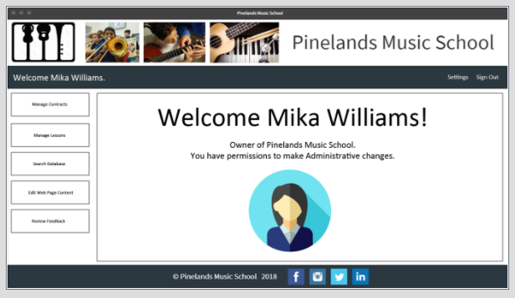

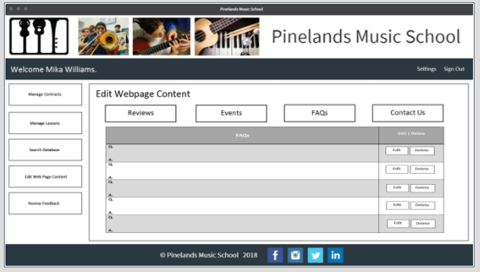

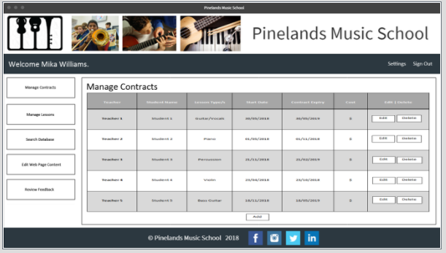

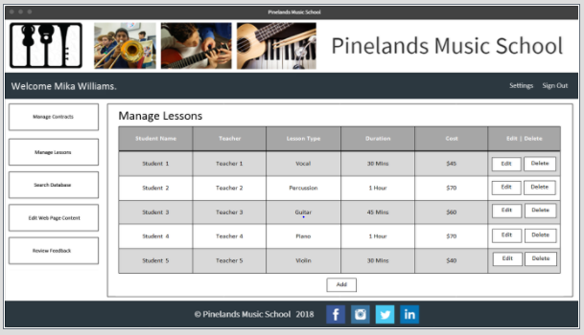

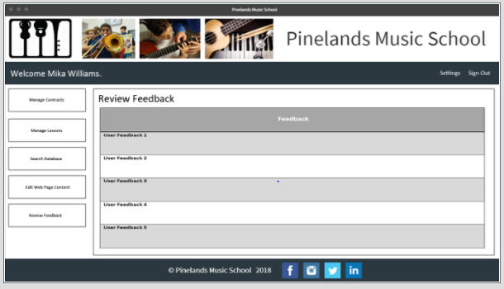

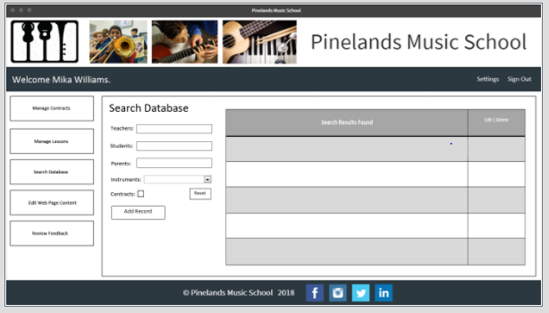

**Artefact 2** – (Justification of Architecture Pattern)

Architecture pattern determines what type of architecture is used in the project and justifies the reasoning for its use. For example, the tier levels of architecture in the website design, which is chosen and how this compares to other architecture patterns.

In terms of the project, it allowed the team to select an architecture pattern and deliver the best solution to the client in terms of clarity, redundancy and speed for their product. It also provided a basis of comparison to other architecture models and the shortcomings they hold in comparison to our chosen architecture pattern.

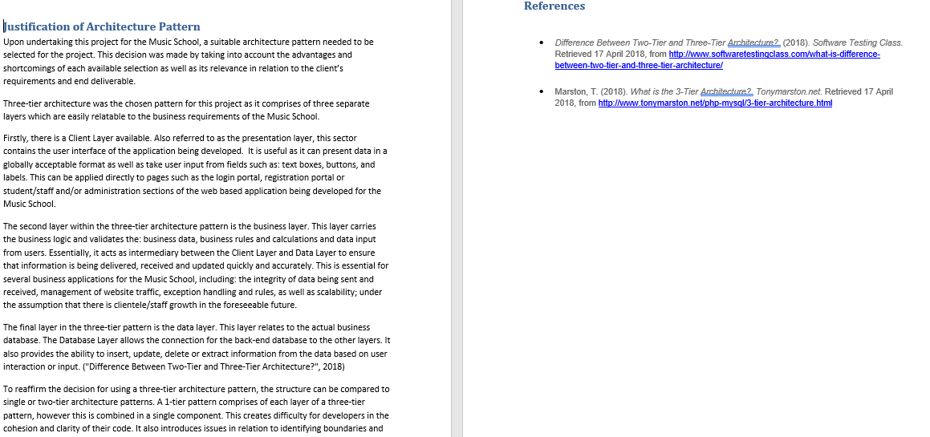

**Artefact 3** – (Meeting Minutes)

Meeting minutes detail the events in each team meeting (scrums). It also takes into account allocated roles, the resource for the role, the estimated time of completion and when/where each meeting took place.

This was useful in the project as it provided clarity on the timeline of events for the week; who is responsible for a task, within what time constraints and what will be discussed in the next meeting. Essentially, it provided a high-level view for each group member of the past week, the present tasks and allocation of future tasks and their estimated time of completion.

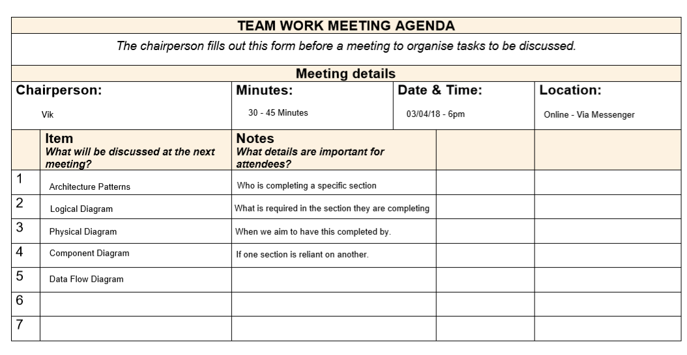

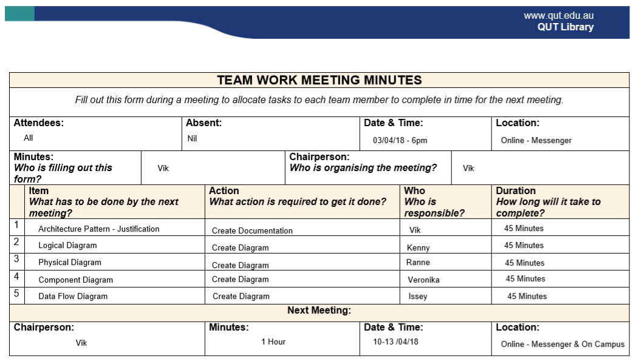

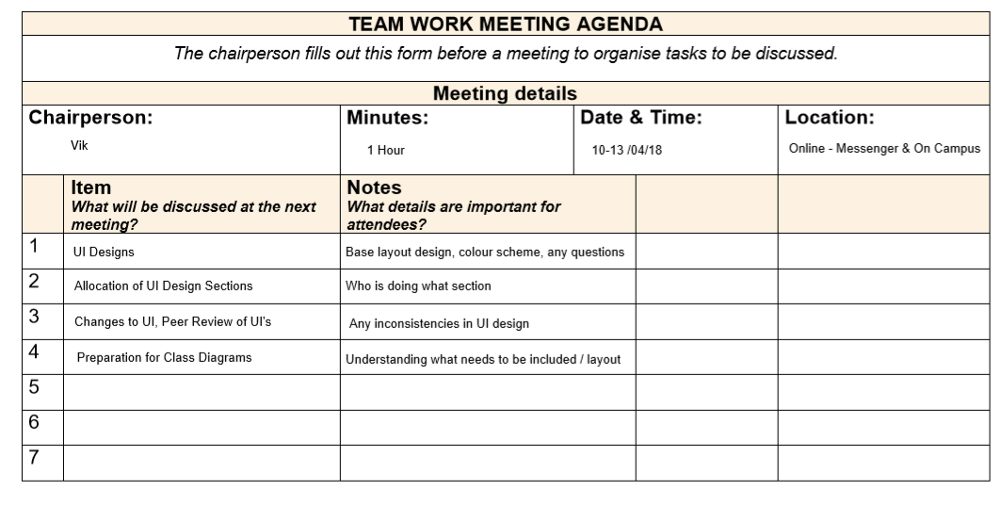

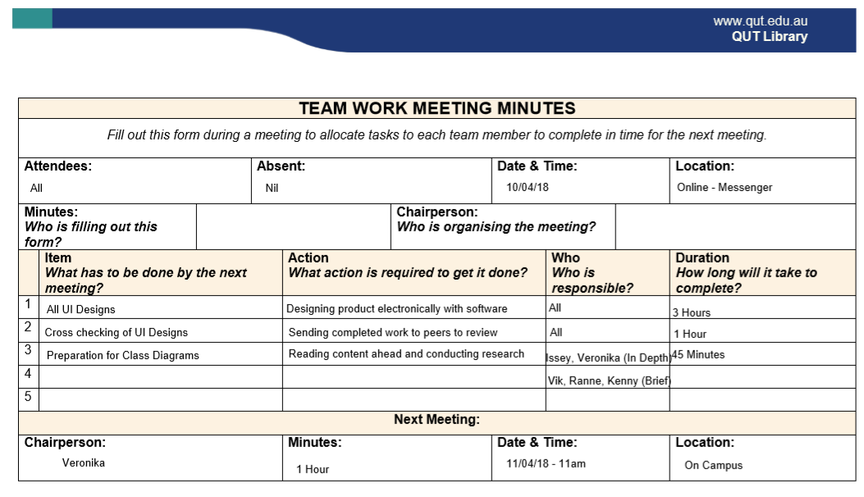

**Artefact 4** – (Class Diagram)

The Class Diagram is another graphical interpretation of the web design project, relating primarily to software design and coding elements that are required.

A class diagram is useful as it lays the foundations for the coding requirements. It also provides a structure for programmers to follow and entails what commands or queries needs to be included in what segment. In doing so, assists the coders to understand which actors have what interactions in each specific piece of code. Furthermore, having a class diagram removes redundant or recycled code, aiding in clarity and cohesion in the overall product.

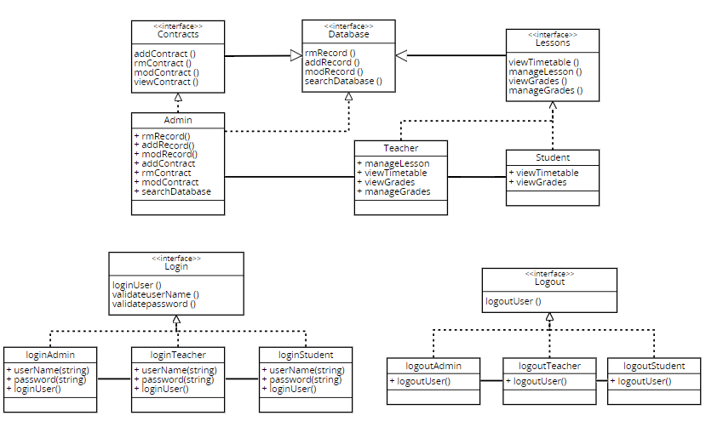

**Artefact 5** – (BPMN Models for Processes)

Business Process Model Diagrams were created to assist in understanding the different processes that occur. BPMN models provide a visual representation of each process individually and the set of instructions or steps taken to complete an action.

This contributes to the project so that the team and Pinelands Music School can understand the individual actions within a process. The models visually depict the separation of user categories and what actions are available to a user based on what class they fit into, e.g. Administrator, Teacher or Client (Student or Parent).

